**Color Image Processing :**

The RGB color model is one of the most widely used color representation method in computer graphics. It uses a color coordinate system with three primary colors:

R(red), G(green), B(blue)

Each primary color can take an intensity value ranging from 0(lowest) to 1(highest). Mixing these three primary colors at different intensity levels produces a variety of colors. The collection of all the colors obtained by such a linear combination of red, green and blue forms the cube shaped RGB color space.

In the RGB color model, an arbitrary color within the cubic color space can be specified by its color coordinates: (r, g.b).

**Example:**

(0, 0, 0) for black, (1, 1, 1) for white,

(1, 1, 0) for yellow, (0.7, 0.7, 0.7) for gray

Color specification using the RGB model is an **additive process**. We begin with black and add on the appropriate primary components to yield a desired color. The concept of RGB color model is used in **Display monitor**.

RGB stands for red, green and blue, which are primary colors. The RGB model is better known as an additive model because the colors are added together to create the images we see on the computer screen. When light from the screen is projected onto the colors, it bleeds them together on the eye’s retina, creating the desired colors, AKA the way we actually perceive colors to be.

*Additive Model*

Additive colors, a projected light color system, are created by a method that combines a number of different light colors together. All the colors begin with black,  or the absence of light, then different colors (or lights) are added to produce visible colors.  Red, green and blue are the main primary light colors that are used in the additive model. The combination of two of these colors will create a *secondary* additive color: cyan, magenta or yellow.

[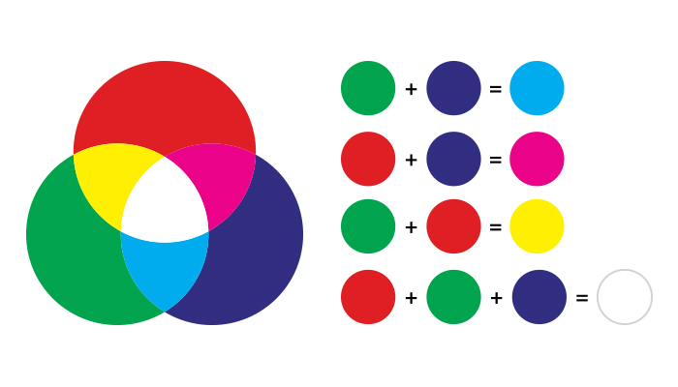](https://gp-ddc-blog01.gotprint.com/wp-content/uploads/2017/11/GP_Blog-Post_120.jpg)

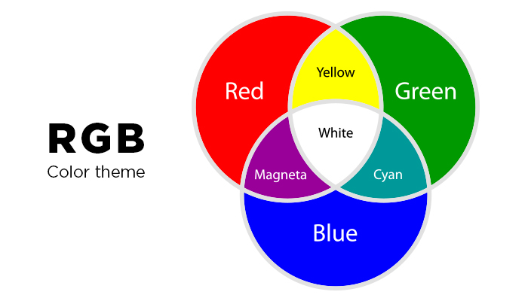

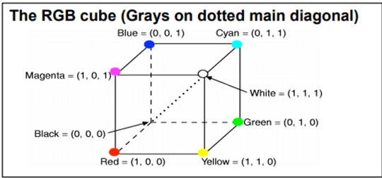

On the other hand, there is a complementary color model known as **CMY color model**. The CMY color model use a **subtraction process** and this concept is used in the **printer**.

In CMY model, we begin with white and take away the appropriate primary components to yield a desired color.



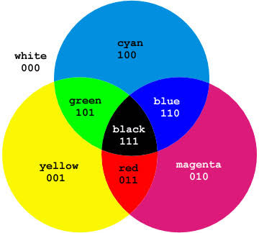

The corner of the CMY color cube that is at (0, 0, 0) corresponds to white, whereas the corner of the cube that is at (1, 1, 1) represents black. The following formulas summarize the conversion between the two color models:

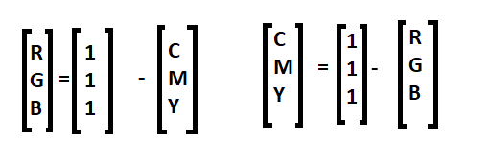

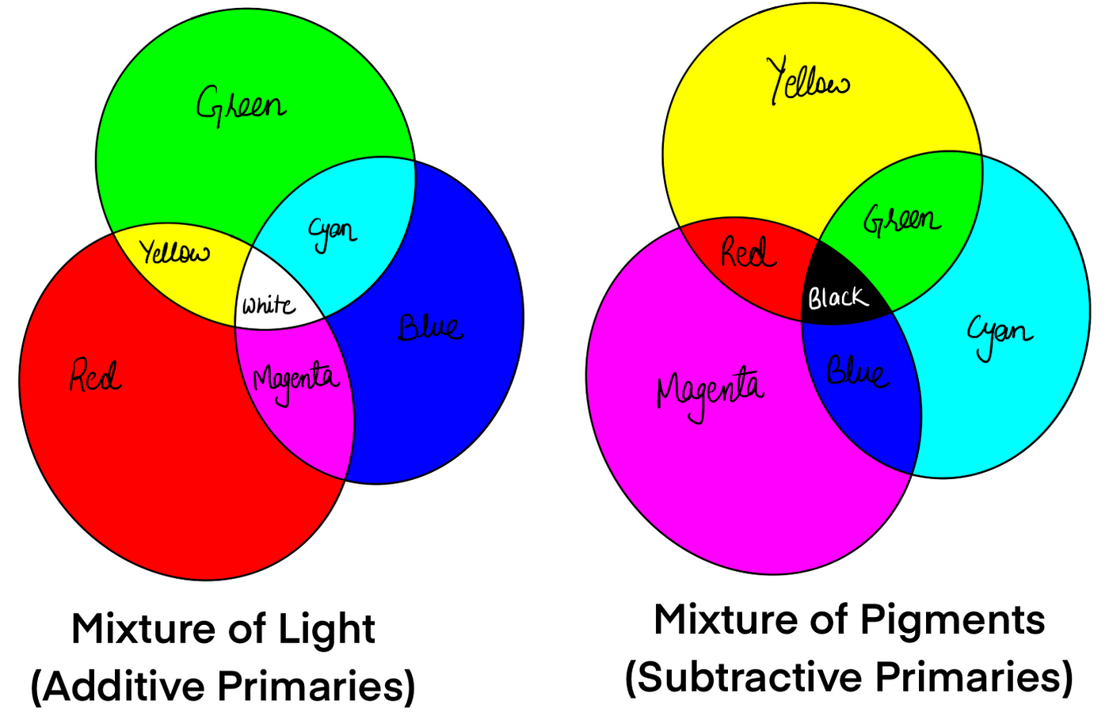

**Example:**  
If we subtract red from white, what remains consists of green and blue which is cyan. The coordinate system of CMY model use the three primaries’ complementary colors:

C(cray), M(magenta) and Y(yellow)

**Introduction of CMY Color Model**

**The CMY color model** is a subtractive color model that is used in printing and other color reproduction applications. CMY stands for Cyan, Magenta, and Yellow, which are the primary colors of ink used in printing. The CMY color model is based on the principle of subtractive color mixing, which involves subtracting colors from white light to create a desired color.

 C(Cyan), M(Magenta) & Y(Yellow)

In the **CMY color model**, colors are created by subtracting different amounts of cyan, magenta, and yellow ink from a white background. When all three colors are combined at full strength, they create black. However, because the process of subtracting color can result in a loss of brightness and saturation, black ink is often added to improve the overall color quality.

[**Explain RGB Color Model in Details with Images**](https://codegyan.in/articles/explain-rgb-color-model-in-details-with-images.htm)

To understand how the CMY color model works, it is helpful to think of it in terms of the color wheel. The primary colors of cyan, magenta, and yellow are positioned evenly around the wheel, with secondary colors such as red, green, and blue located between them. To create a specific color, ink is subtracted from white to produce the complementary color on the color

wheel.      For example, to create the color red, magenta and yellow ink are combined. The magenta ink subtracts the green portion of white light, while the yellow ink subtracts the blue portion, leaving only the red. To create the color green, cyan and yellow ink are combined, with the cyan ink subtracting the red portion of white light and the yellow ink subtracting the blue portion, leaving only green.

**Advantage of CMY Color Model**

One of the main advantages*of the CMY color model* is its ability to produce a wide range of colors using a relatively small number of inks or colorants. Unlike additive color models, such as RGB, where colors are created by combining light of different wavelengths, the CMY color model works by subtracting light of certain wavelengths from white light to create different colors. For example, when cyan ink is applied to a white surface, it absorbs red light and reflects green and blue light, creating the color cyan.

The subtractive nature of the **CMY model allows** it to produce a wide range of colors by combining different amounts of cyan, magenta, and yellow. By adding more of each colorant, the resulting color becomes darker, eventually approaching black when all three are combined in equal amounts. This makes the CMY model particularly useful in printing applications, where a limited number of inks must be used to produce a full range of colors.

Another **advantage of the CMY color model**is its compatibility with other subtractive color models, such as the Pantone Matching System (PMS) used in the printing industry. By using the CMY model as a basis, printers can accurately reproduce a wide range of PMS colors using a combination of cyan, magenta, yellow, and black inks. Overall, the CMY color model offers a cost-effective and flexible approach to color reproduction, making it a popular choice in a variety of industries, including printing, graphic design, and photography.

**CMY CUBE**

